|  |
| --- |
| Øvelsesrapport: Finger maze |
| Roselil Aalund  Sebastian Beck  Frederik Bredgaard  Cecilie Strandsbjerg |
| 25/09-2019 |

Index

Introduction 3

Method 3

Materials 3

Test procedure 3

Results 4

Eliminating errors through trials 4

It takes a while to learn a maze 5

Some cognitive processing involved in the learning process 7

Correlation at criterium and first trial 8

Conclusion 8

References 9

# Introduction

This paper examines learning processes using a finger maze experiment.

One theory on learning is operant conditioning (Terry, 2016). Within this paradigm, Edward Thorndike’s law of effect states that a mechanistic learning happens through trial-and-error. Throughout this trial-and-error experimentation, behaviours that are rewarded get reinforced and therefore are increasingly more likely to be repeated in the future (Olson & Hergenhahn, 2016). From this point of view, we would expect the finger maze to be learned as a kinaesthetic motor sequence.

Edward C. Tolman presents learning as a cognitive process in which one’s expectations are confirmed or disproven. From such data the organism might develop a cognitive map of the environment it is navigating (Olson & Hergenhahn, 2016). From this, we would expect learning of the finger maze to include a cognitive component.

Our data should give us an indication of how learning occurred.

# Method

This experiment included *N* = 49 participants, all psychology students at UCPH. Age and sex differences were not considered.

## Materials

* Finger maze
* Blindfold
* Stopwatch

## Test procedure

Present during the experiment was the experimenter (E), two observers (OBs) and a research participant (P). Before each test, the RP was briefed by E. The experiment consisted of three tests and all were performed blindfolded. For all tests, the test criterium was fulfilled upon three consecutive flawless completions of the maze.

In test A, the P was asked to find the route from entrance to exit of the maze. Each run was timed (RT) by OBs, and RT was measured from when P started moving their finger until the exit was reached. Number of errors was recorded by OBs – any deviation from route, or moving backwards in the maze, were counted as a single error (length or complexity of deviation regardless). The P used the index finger of the dominant hand.

Test B was a repetition of test A but P used the index finger of the nondominant hand.

In test C, the conditions were the same as in test A, but the P had to find the way from the exit to the entrance.

# Results

## Learning across trials

A repeated measures ANOVA was conducted to test whether number of errors made in the first ten trials varied significantly between tests.

This showed a significant main effect of test on number of errors, *F*(1.037, 49.789) = 50.61, *p* < .001, $η_{p}^{2}$ = .51 (Huynh-Feldt corrected), as well as a significant main effect of trial number on errors, *F*(2.086, 100.134) = 11.52, *p* < .001, $η_{p}^{2}$ = .19 (Huynh-Feldt corrected). Further, the test showed a significant interaction between test and trial, *F*(2.161, 103.721) = 8.54, *p* < .001, $η_{p}^{2}$ = .15 (Huynh-Feldt corrected),

This means that number of errors depend on the number of the trial.

As Figure 1 shows, Ps made more errors in test A with number of errors decreasing throughout trials. Figure 2 reveals a similar pattern for FP19202.

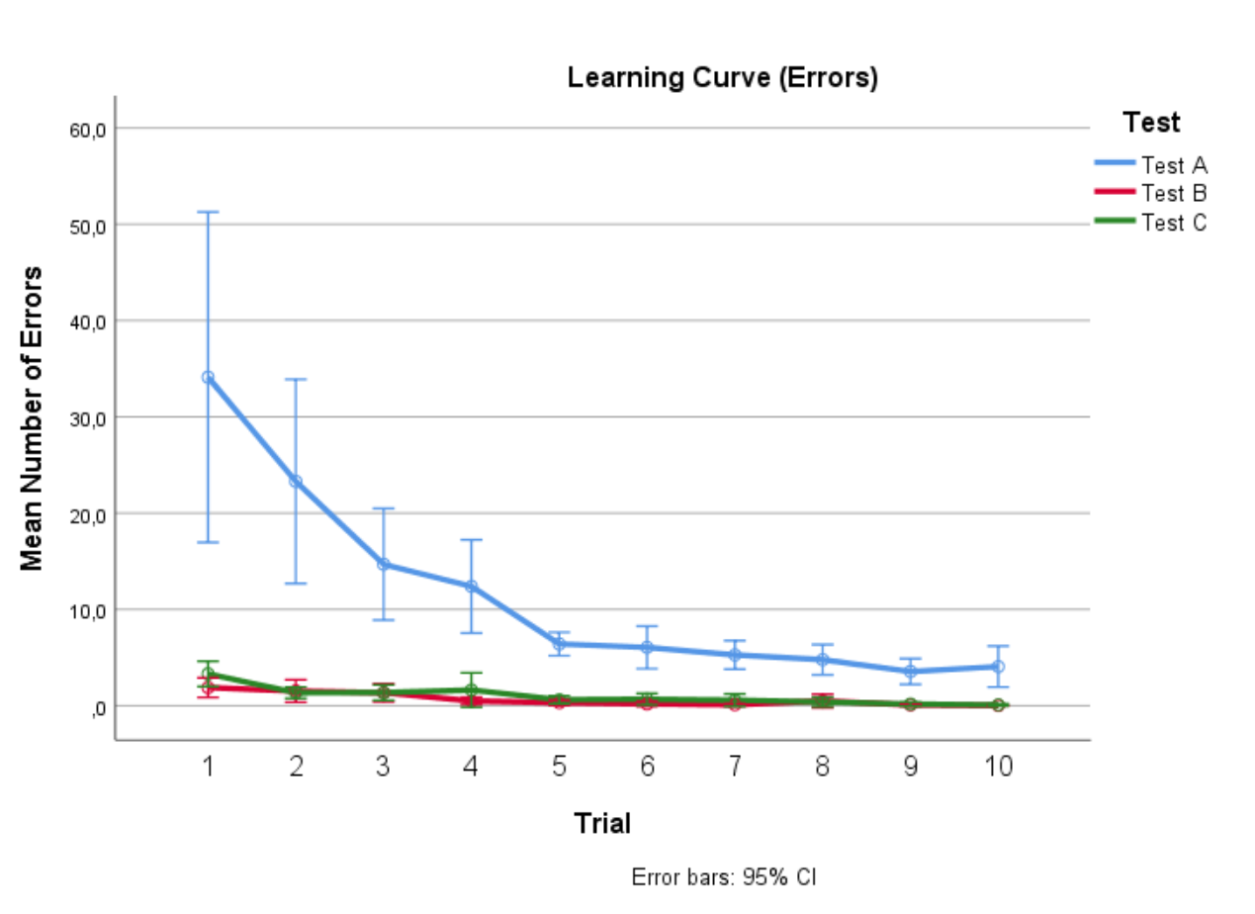

Figure 1: Graph showing Learning Curve for sample.

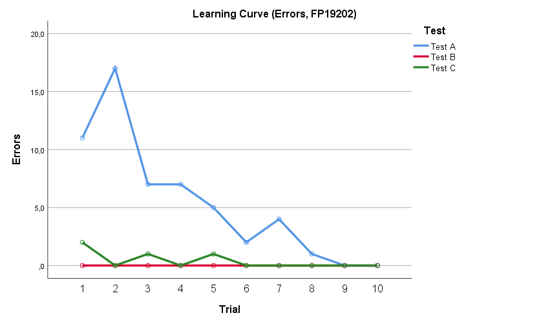

Figure 2: Graph showing number of errors for FP19202

## Learning across tests

A repeated measures ANOVA was conducted to test whether there was a significant difference in RT between the first ten trials of each test.

The test showed a significant main effect of test on RT, *F*(2, 96) = 15.89, *p* < .001, $η_{p}^{2}$ = .25 (Huynh-Feldt corrected), and a significant main effect of trial number on RT, *F*(1.616, 77.544) = 85.67, *p* < .001, $η_{p}^{2}$ = .64 (Huynh-Feldt corrected). The test showed a significant interaction between test and trial, *F*(2.199, 105.546) = 8.27, *p* < .001, $η_{p}^{2}$ = .15 (Huynh-Feldt corrected).

Figure 3 displays longer RT for test A than other tests and decreasing RT during trials. Critically, first trial RT is lower in tests B and C than test A, indicating transfer of learning across tests. Figure 4 displays a similar pattern for FP19202.

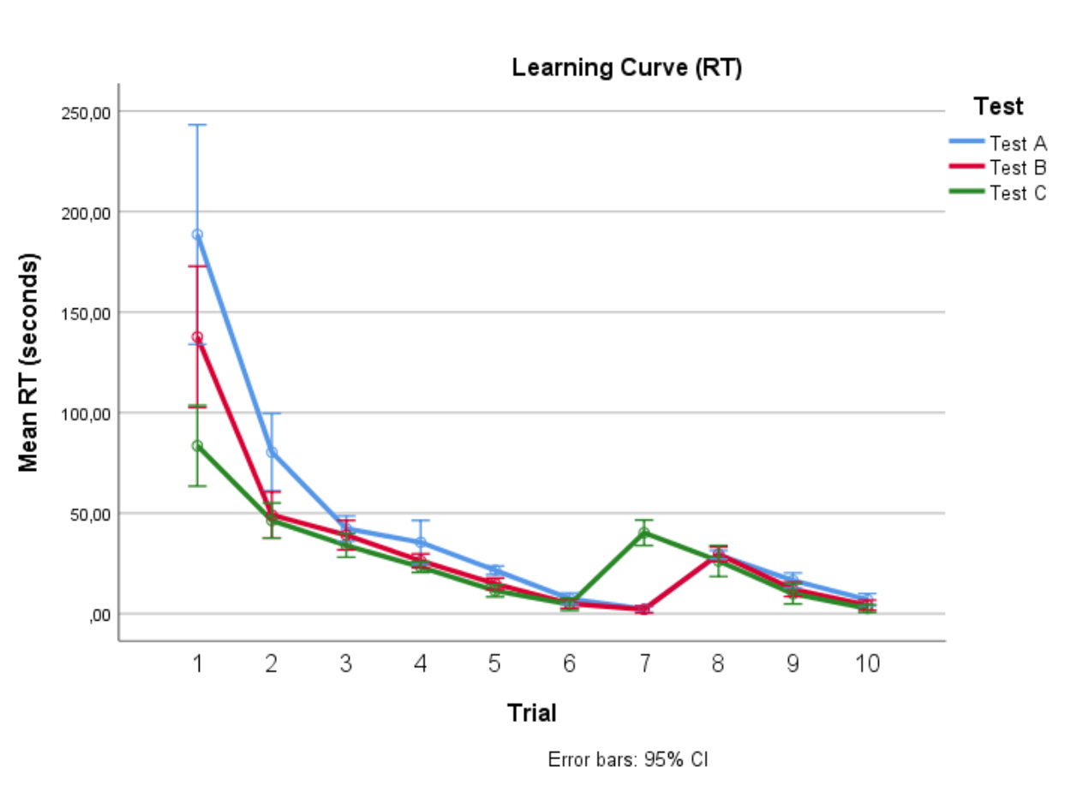

Figure 3: Graph showing mean RT for sample.

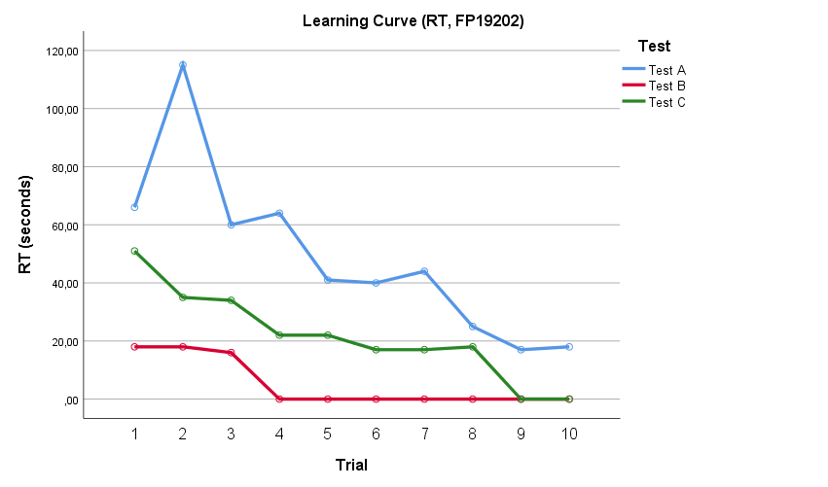

Figure 4: Graph showing RT for FP19202.

## Some cognitive processing involved in the learning process

*Table 1: Mean errors and RT at first trial, and mean number of trials and RT when criterium was reached*

|  |  |  |  |  |  |  |  |  |
| --- | --- | --- | --- | --- | --- | --- | --- | --- |
| *N* = 49 | First trial | | | | At criterium | | | |
| Errors | | RT | | Mean trial number | | RT | |
|  | *M* | (*SD*) | *M* | (*SD*) | *M* | (*SD*) | *M* | (*SD*) |
| Test A | 34.11 | 59.72 | 188.62 | 190.11 | 22.12 | 12.64 | 18.54 | 5.05 |
| Test B | 1.88 | 3.55 | 26.27 | 11.95 | 5.90 | 3.41 | 17.88 | 3.90 |
| Test C | 3.31 | 4.57 | 40.24 | 21.98 | 6.80 | 3.35 | 26.26 | 28.07 |

Paired samples *t*-tests showed significant differences in mean number of errors in the first trial between tests A (*M* = 34.11, *SD* = 59.72) and B (*M* = 1.88, *SD* = 3.55), *t*(48) = 3.87, *p* < .001, *d* = 1.02, between tests A and C (*M* = 3.31, *SD* = 4.57), *t*(48) = 3.69, *p* = .001, *d* = 0.96, and between tests B and C, *t*(48) = -2.47, *p* = .017, *d* = 0.35.

This means number of errors for first trial differed significantly between all tests.

Further paired samples *t*-tests showed significant differences in RT in the first trial between tests A (*M* = 188.62, *SD* = 190.11) and B (*M* = 26.27, *SD* = 11.95), *t*(48) = 6.05, *p* < .001, *d* = 1.61, between tests A and C (*M* = 40.24, *SD* = 21.98), *t*(48) = 5.47, *p* = .001, *d* = 1.40, and between tests B and C, *t*(48) = -4.48, *p* = .017, *d* = 0.82.

This means RT for first trial differed significantly between all tests.

Paired samples *t*-tests also showed significant differences in mean number of trials at criterium between tests A (*M* = 22.12, *SD* = 12.64) and B (*M* = 5.90, *SD* = 3.41), *t*(48) = 8.82, *p* < .001, *d* = 2.02, and between tests A and C (*M* = 6.80, *SD* = 3.35), *t*(48) = 8.56, *p* = .001, *d* = 1.92, and no such significant difference between tests B and C, *t*(48) = -1.39, *p* = .17, *d* = 0.27.

These results present test A as the most *initially* requiring test in terms of time needed and errors made. This was expected, as test A represents the *initial* learning of the maze’s layout. Tolman would argue that the essence of learning is the cognitive processes occurring between stimuli and responses, e.g. the establishment of a cognitive map (Terry, 2016). This provides an explanation for the increased number of trials needed to complete test A, as well as increased RT and number of errors at first trial for test A, compared to tests B and C, as a cognitive map would have been established prior to the initiating of tests B and C.

Further paired samples *t*-tests showed a significant difference in mean RT at criterium between tests B and C, *t*(48) = -2.11, *p* = .04, *d* = 0.52, but no such significant differences between tests A (*M* = 18.54, *SD* = 5.05) and B (*M* = 17.88, *SD* = 3.90), *t*(48) = 1.18, *p* = .24, *d* = 0.15, or between tests A and C (*M* = 26.26, *SD* = 28.07), *t*(48) = -1.94, *p* = .06, *d* = 0.47.

## Learning occurred during trials

A two-tailed Pearson correlation shows no significant correlation between RT at criterium, and number of errors at first trial (*r =* -.04, *p =* .80), and no significant correlation between RT at criterium and RT at first trial (*r =* .05, *p* = .74).

As the first and last trials are not significantly correlated, learning must have occurred, and we conclude that our experiment targets learning processes rather than individual differences.

# Conclusion

Our results provide support for the notion that at least some cognitive processing is involved in the learning of a finger maze. Whether such processing specifically results in the production of a cognitive map remains unclear and may vary between subjects.

# References

Olson, M. H., & Hergenhahn, B. R. (2016). *An Introduction to theories of learning* (9th ed.). New York: Rout.

Terry, W. S. (2016). *Learning and Memory - Basic Principles, Processes, and Procedures*. *IEEE Transactions on Information Theory* (4th ed., Vol. 58). New York: Routledge.